# ***ANALYSIS OF RE-OCCURING & EXPENSIVE MEDICAL PROCEDURES***

Ritika Joshi



California State University, Los Angeles

CIS-5210 Healthcare Data Analytics

**INTRODUCTION:**

Lengthy medical procedures are not only tiring but also quite expensive. Affordable Care Act introduced a few years ago was emphasized to provide medical care to everyone irrespective of whether patient earns enough to afford the expensive treatments of critical diseases or not. This study is focused on medical procedures which have the most tendency of re-occurring. For the lengthy procedures involved, we analysed what factors a patient faces while going through them. For this study, we picked Readmit Historical data set which includes detail of the patients admitted to the hospitals over different countries from 2011 to 2012 and suffered from critical diseases like Heart failure, pneumonia, bronchitis, etc. Along with the basic details like age, city, country, department of the patients, this data set also included date of admit, length of stay, date of discharge, date of re-admit, diagnosis description, days in the ICU, operation count, total charge incurred etc. These details will help in predicting at what general age or age group which diseases should be tested and if there is any pattern of dominance based on gender. This study will also help in predicting a rough cost estimate for patients based on their diagnosis type.

**GOALS:**

The goal of this analysis is to find out which diseases needed immediate attention to treat the patients at early stages. As per the report from American National Institute of health, there is ever increasing need to provide a platform through which everyone could afford the super expensive treatments of life threatening diseases[6]. Using SAS Visual Analytics, we achieved this goal by analysing the following questions:

Which diseases show the maximum number of operations?

Whether there is any correlation among the provided data set?

What is the average age of patients for these diseases?

Which gender is prone to which disease?

What could be the minimum and maximum charge incurred for patients based on the diagnosis type?

**DATA EXPLORER**

1. Rank the diseases per the total number of operation count and ICU days

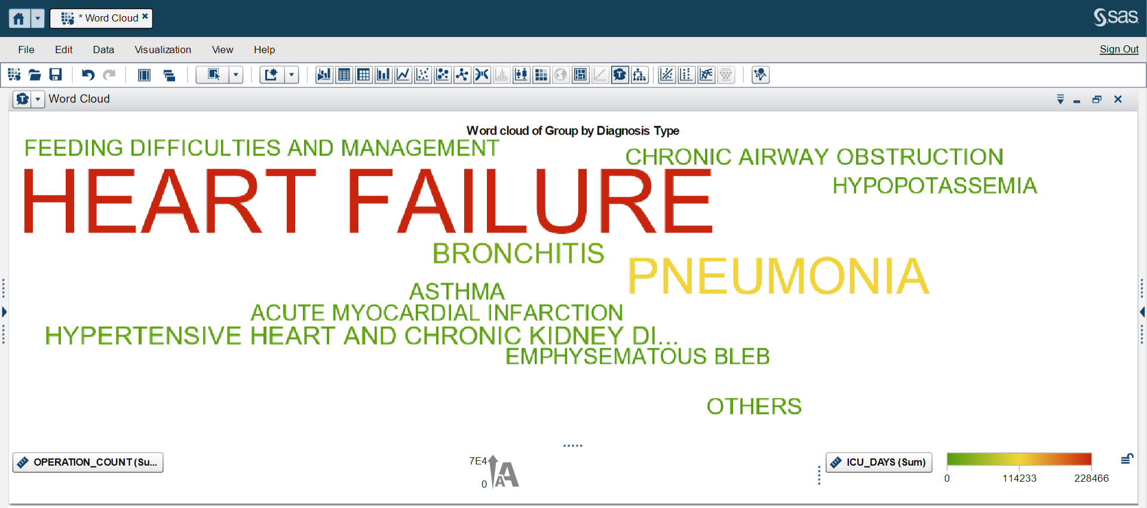

Interpretation:

To rank the diseases based on their criticality, we created a new category called ‘Group by Diagnosis Type’ by grouping ‘diagnosis_long_desc’ using common keywords in the diagnosis description values. Using word cloud, we tried to visualize which diseases dominated the total count of operations over 2011-2012. From this visual one can infer that, the higher the number of operations, the bigger the size of the disease. By this we conclude, that the highest number of operations that are done for ‘Heart Failure’ followed by ‘Pneumonia’. Also, ‘Heart Failure’ patients face the maximum number of ICU days.

1. **Influence of factors on each other**

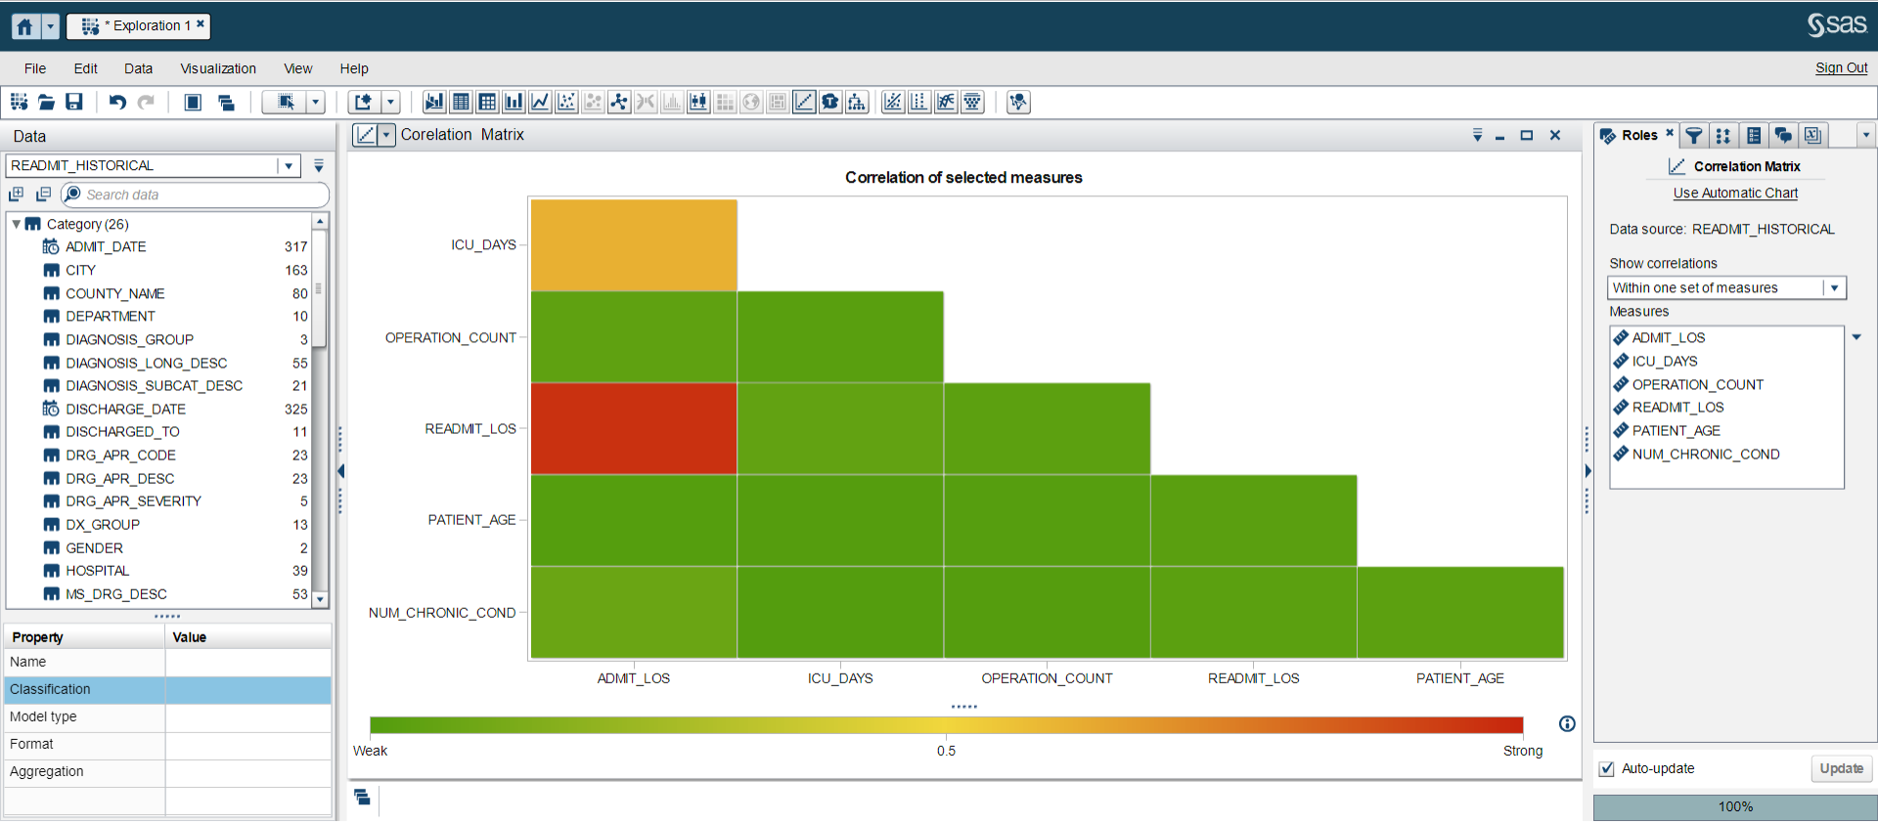

Interpretation:

The purpose of this correlation matrix in this study was to analyse which factors have influence on each other, hence we could choose our factors wisely to move forward with the analysis. As per the correlation matrix shown above, there is a very strong relation between length of stay and readmit length of stay, concluding that a patient’s length of stay per admit is same on average.

Also, there is good relation between length of stay and ICU days; which leads us to conclude that ICU days count and length of stay are directly proportional. Operation_Count, Patient_Age, Num_Chronic_Condition has shown weak relationship with others.

1. Average age of patients at the time of diagnosis

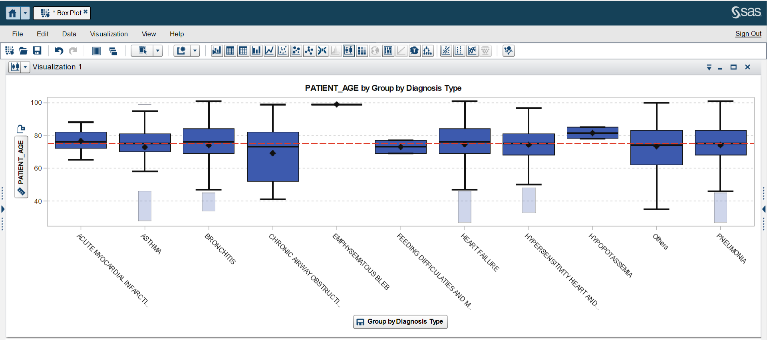

Table of the visualization details

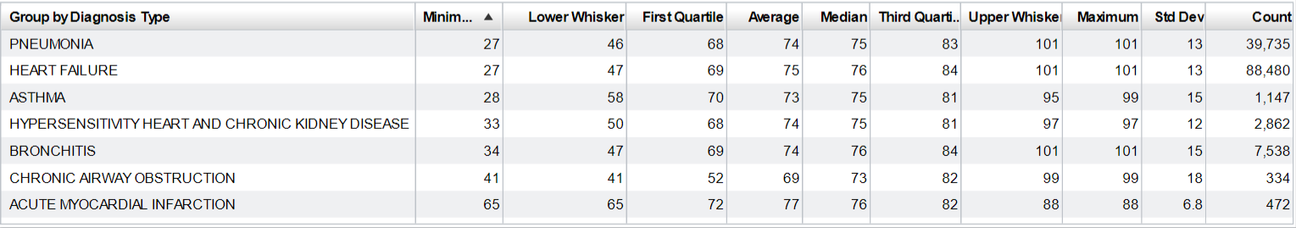

Interpretation:

After filtering out a few non-prominent diagnosis types in the visual, one can conclude that for all the diagnosis types, average age and median age is in the range 73-77. Standard deviation, 18 is highest for Chronic Airway Obstruction. The visual plot also shows the outliers (in light blue) for Asthma, Bronchitis, Heart Failure, Hypersensitivity heart and chronic kidney disease, and pneumonia. Focusing on Heart Failure and Pneumonia, outliers are the ages 27-47 and 27-45 respectively.

1. Comparison of frequency of occurrence of disease in Males and Females

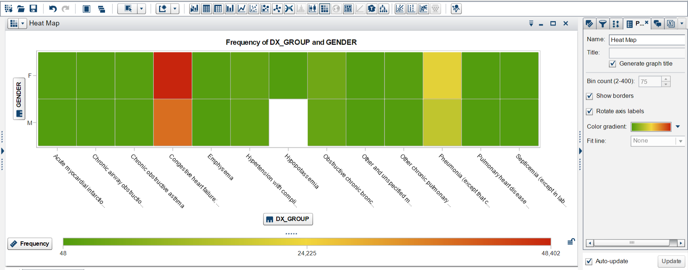

Interpretation:

The frequency of congestive heart failure is very high. Although it is highest among females, among males the frequency of occurrence is noticeably high as well. Surprisingly there is no case of hypopotassaemia among males. For Pneumonia, frequency of occurrence among both of Females and Males is almost equal.

1. Average length of stay for each diagnosis type

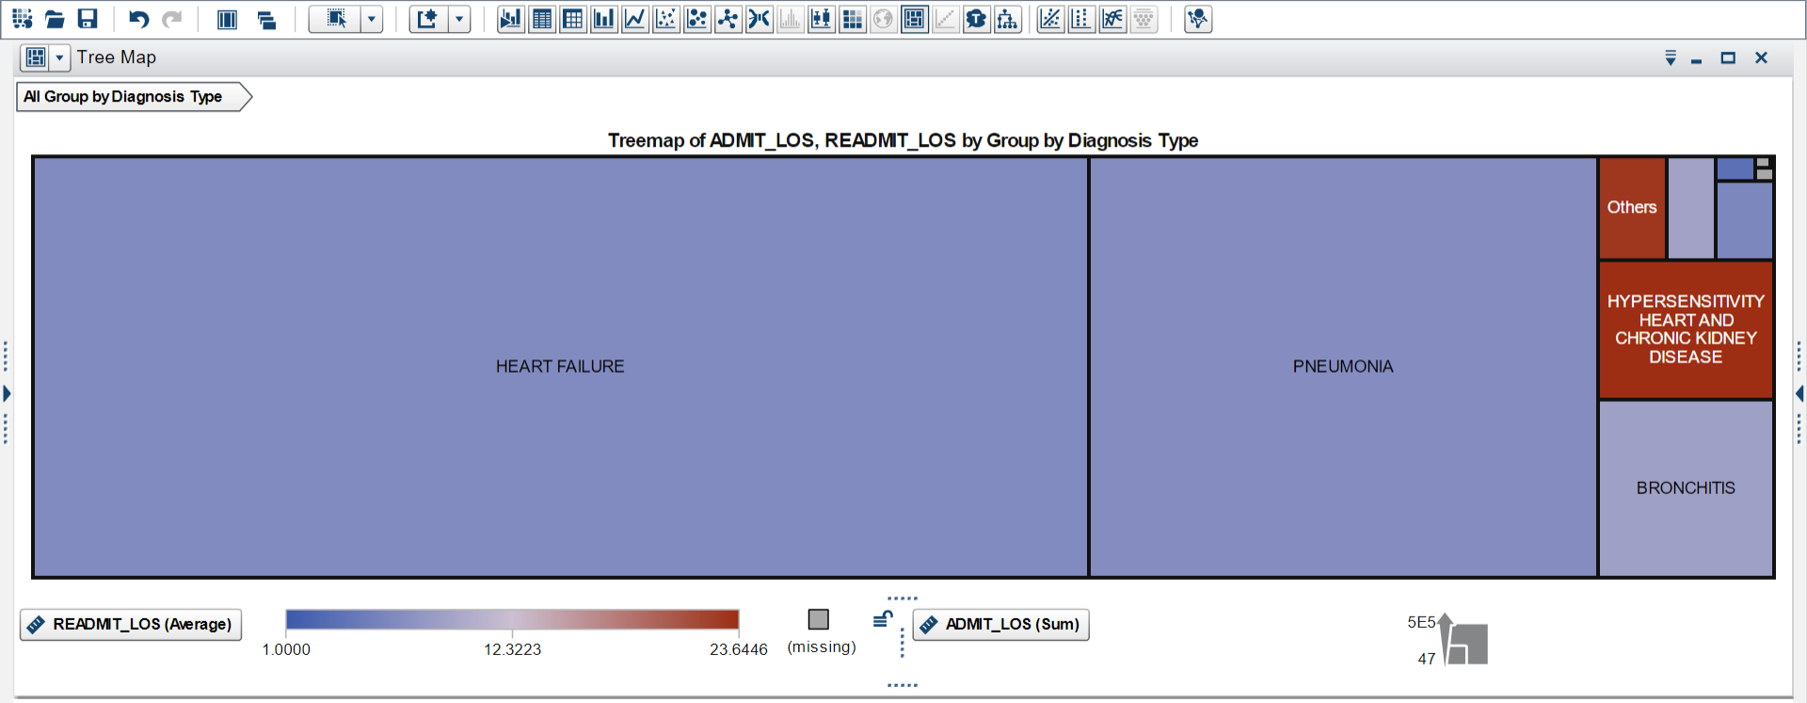

Interpretation:

First LOS of admit is highest for Heart failure followed by pneumonia and bronchitis. On the contrary average re-admit LOS for these diseases is almost 1. From this visual one can infer that patients suffering from one these three diseases might stay longer than other patients but they do not need to return for stay in the facilities for further part of the treatment. They might need to stay longer on one go for surgical procedures, but it needs to be verified with more study.

**REPORT DESIGNER**

1. Pattern of Total Charges based on the number of visits for ‘Transplant’

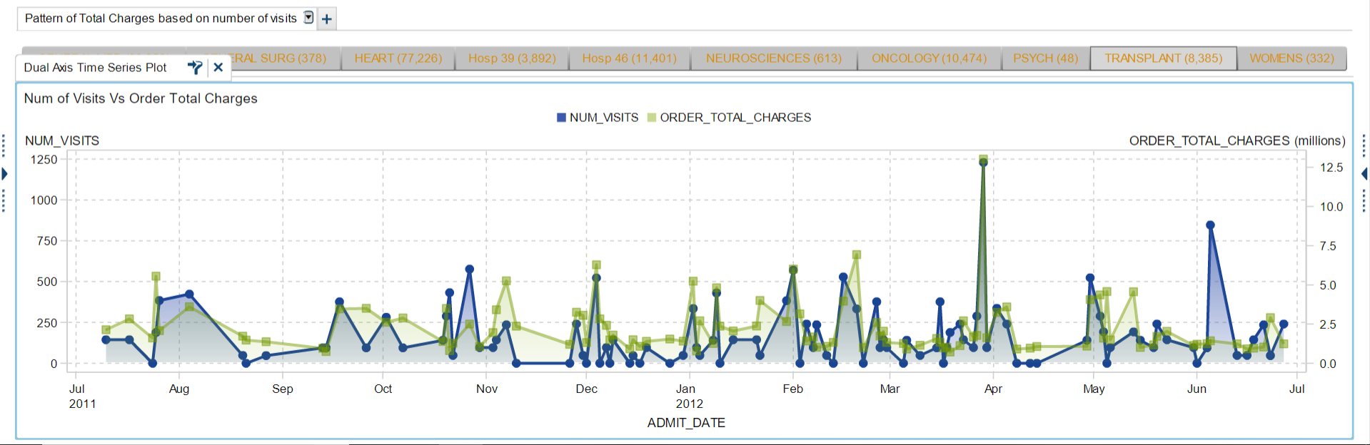

Interpretation:

Transplants are one of the most expensive procedures, for which patients suffer a long wait in the transplant list. In this report our focus remains on the department related to Heart procedures like ‘Transplant’. Looking at the above report we can conclude that total charges for a transplant stay is in the range of 2 million to 5 million dollars for number of visits ranging from 100 – 500. It is difficult to ignore a few outliers where in the month of March, there were 1250 visits costing 12.5 million dollars; and another one in Jan where for 800 visits the total charge was minimal.

1. Estimate of operation count and ICU days per county

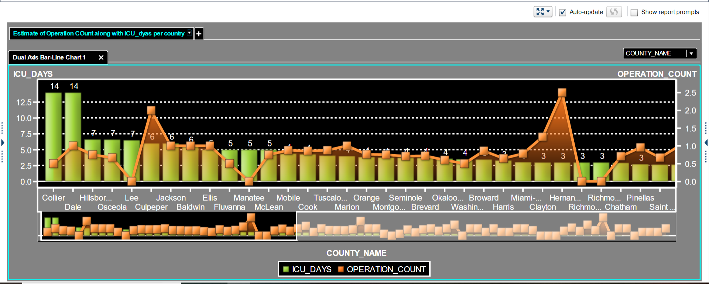

Interpretation:

Using the dropdown in above report, average number of operation count can be checked for average number of ICU days. Except for the Collier and Dale counties who have on average 14 ICU days, rest of the counties have 3 – 7 ICU days on average. Average count of operation is in the range 0 – 3. We can interpret that Collier and Dale have the busiest ICUs and thus patients could be redirected to other nearby counties in case of emergencies and the ICU being unavailable.

**SUMMARY:**

The latest Medical reports published by Marsh in 2018 reported that inflation rate of medical cost has increased by 3 times over a year long period. The Marsh company is investing in Data analytics to build a system for the wellbeing of everyone including employers, employees and insurers to manage the increasing costs and manage health outcomes [1]. Such trends lay emphasis on the analytics of what should be done and undone to improve the current conditions. This study is the outcome of such attention seeking medical situations. It could be noticed early in the study that heart failures, pneumonia and bronchitis are the most demanding diseases. Patterns also show that females suffer from congestive heart failures more as compared to males. The minimum age of a heart failure patient has come out to be 47 which leads to the conclusion that for the betterment of medical conditions for heart failure cases people should start performing certain heart tests at ~45.

On the contrary, the American Lung Association of Research and Health Education Division mentioned in an article that even after the rate of deaths due to pneumonia have decreased by 3.8%, the count of deaths due to the same reason can still not be left unnoticed. [2]. This leads us to believe that preventive care for pneumonia should be included in health plans for the betterment of patients predisposed to it. Also, as noticed in the data set heart failure and pneumonia have an overlap thereby leading us to believe that many patients admitted for one disease must also get tested for the other. Looking at the median age range 73-77 we can incur that employers need not worry about these diseases too much as the age range falls after the general retirement age of 68. Nevertheless, factors affecting the predisposition for an early onset to these diseases like lifestyle choices, smoking and high BMI or obesity must be taken into consideration when laying out medical plans.

Correct diagnosis at an early age is one aspect to improve the current medical situation from the patient’s perspective. Another aspect of improvement could be from hospital’s perspective where the ICUs are always full, and patients wait long for surgeries like transplants. Studies have shown that ICU coverage depends on the mortality rate and LOS but not with lower in-hospital mortality or hospital LOS [3]. Surprisingly on one hand where maximum LOS is seen for heart failure, pneumonia and bronchitis, the result under this study shows average re-admit LOS for these three diseases the least. We can infer two points from this:

1. Patients are admitted for the operations, post which they don’t need to be re-admitted.
2. For diseases under hypersensitivity, patients might need to return frequently, and these treatments are not one time but re-occurring.

First report of this study depicts that among 8,385 cases of transplants the average cost reaches $3 million which is difficult for a person to accumulate at the age of 70-76. Hospitals show the trend of always being busy to serve the patients except for a few days in Nov-Dec where no transplants were done. This needs certain improvement in terms of delivering the best and at the easiest manner to the patients equally. Otherwise, those who could afford expensive treatments will dominate to occupy the operations and those below average income will not only have to work more to accumulate amount but also would have to wait longer than usual. This also brings another view point to be studied, that if this is really happening. However, dominance of rich or races is not covered in this study, but it could be of importance to achieve the basic goal of providing medical facilities.

Along with all of the improvement this study inferred, there is one more improvement that could be brought into practice. That is to redirect the patients to nearby facilities incase of unavailability of beds or ICUs or doctors. As per one of the journals published by Rutgers Center for State Health Policy in 2007 [4], there are insufficient number of facilities. Patients inflow is higher than all of the hospitals in New Jersey counties could intake. Even number of ambulances fell short. For past 10 years the occupancy percent has not inflated much

**References:**

**[1]** "2018 Medical Trends Around the World." *Marsh | Global Leader in Insurance Broking and Risk Management.*Marsh, 2018. Web. 13 Apr 2019.

[2] "Trends in Pneumonia and Influenza Morbidity and Mortality." *American Lung Association.*Nov 2015. Web. 14 Apr 2019.

[3] Young LB, Chan PS, Lu X, Nallamothu BK, Sasson C, Cram PM. Impact of telemedicine intensive care unit coverage on patient outcomes: a systematic review and meta-analysis

[4] DeLia, Derek . "Hospital Capacity, Patient Flow, and Emergency Department Use in New Jersey." *The Official Web Site for The State of New Jersey.*Rutgers Center for State Health Policy, Sep 2007. Web. 14 Apr 2019.

[5] "• Hospital occupancy rate U.S. 1975-2017 | Statistic." *• Statista - The Statistics Portal for Market Data, Market Research and Market Studies.*Web. 14 Apr 2019.

[6] Vogenberg,, F. Randy and John Santilli. "Healthcare Trends for 2018." *National Center for Biotechnology Information.*Am Health Drug Benefits, 11 Feb 2018. Web. 14 Apr 2019.